I


Contemporary Business Economics

II
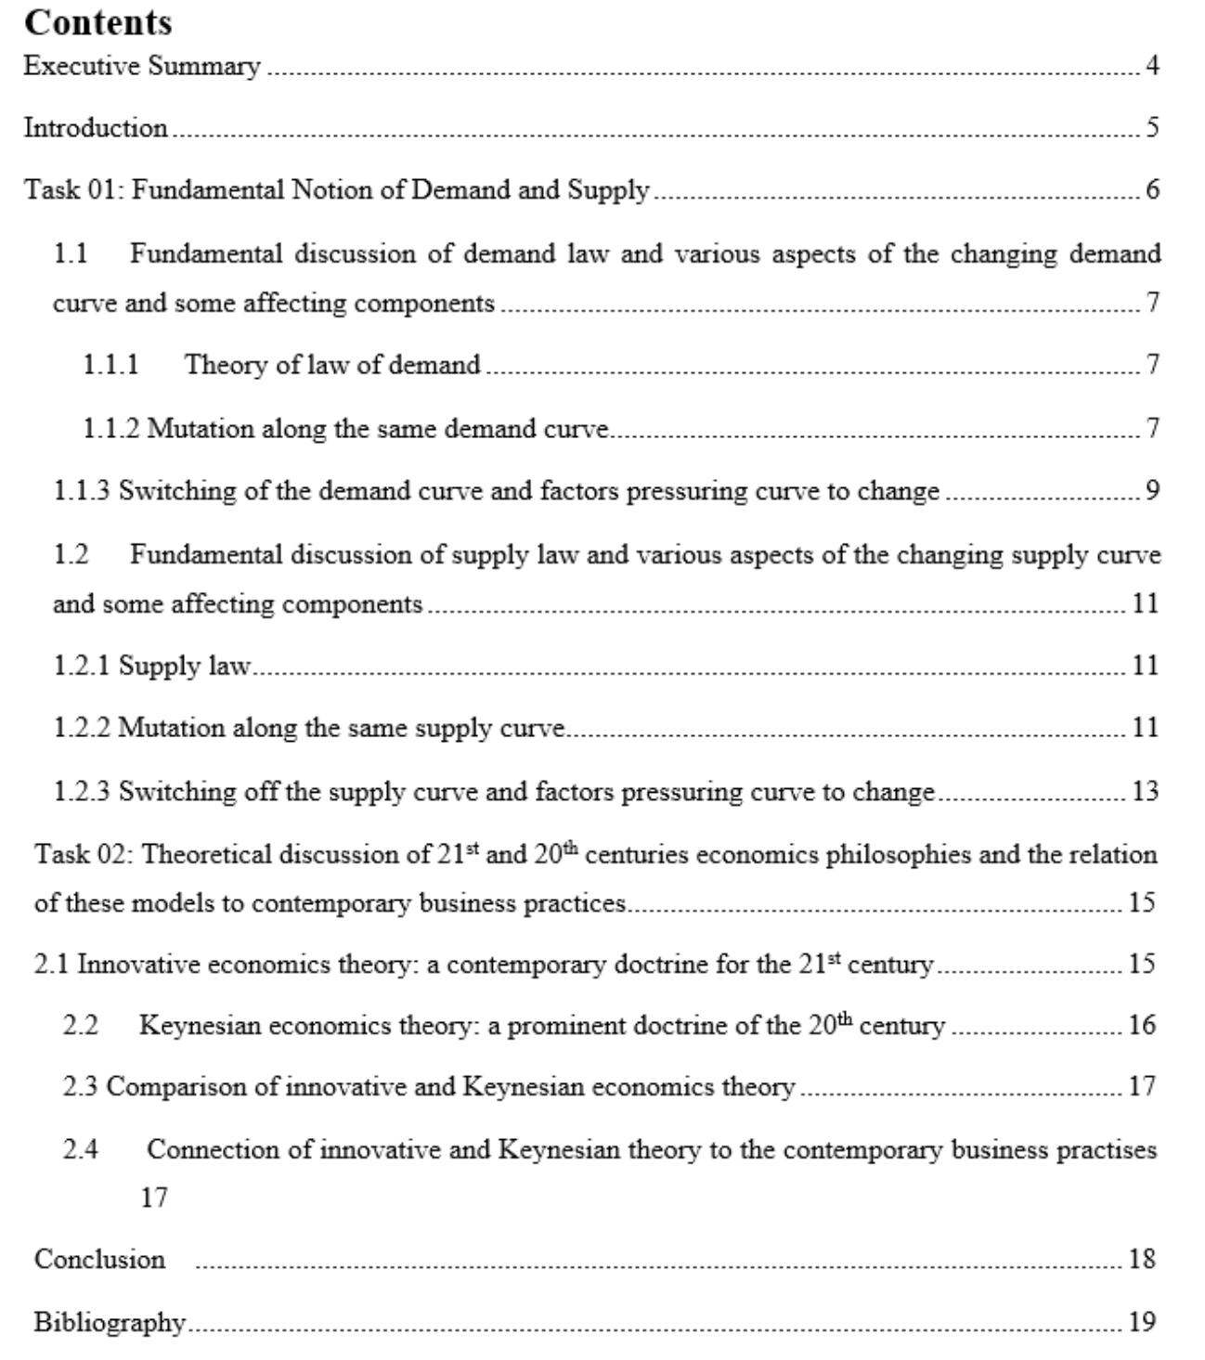

III
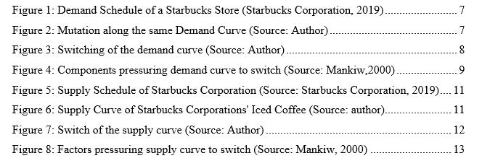

IV

Executive Summary

This assignment is divided into two parts called Task 1 & 2. In the Task 1, fundamental notion of demand and supply will be discussed. Converse relation between price and demand indicates law of demand and positive relation between price and supply indicates law of supply. Mutation along the law and supply curve happens when price forces demand and supply to be changed while determinants of demand and supply remain static. Determinants of demand and supply forces supply and demand curve to be switched. And the effects of demand and supply determinants will also be discussed in the Task 1. In the Task 2, one of the 21st centuries best economics theories is innovation theory which main theme is that knowledge, innovation, information are the basis of economic growth and Keynesian theory introduced in 20th century which main theme is that high spending in consumption, investment, government expenditure are the basis of economic growth will be discussed. Comparison between the innovation theory and the Keynesian theory and the relation among these theories and contemporary business practises will be discussed at the end of this assignment.

V

Introduction

This study deals with the basic notions of macroeconomics like theory of law and supply, switch and change of supply and demand curve and related factors in the task-01. And in the task-02, contemporary business models like- innovative economics theory and Keynesian theory will be discussed and their relation to the modern business practises will also be discussed. Besides the illustration of demand and supply schedule and curve, how income, price of substitute and complement products forces demand curve to be changed will also be presented. After that, how production factors, technological condition, number of producer force supply curve to be shifted will also be discussed. At the end, how PPP and innovation change the contemporary business practises as suggested by innovative and Keynesian theory will be presented.

VI

Task 01: Fundamental Notion of Demand and Supply

VII

1.1 Fundamental discussion of demand law and various aspects of the changing

demand curve and some affecting components

1.1.1 Theory of law of demand

When price goes up, the demand of a certain product or service decrease and when the price goes down, the demand of a certain product or service decrease; and this converse connection between price and demand indicates the demand law (Whelan and Msefer, 1996). The main reason behind this converse connection is the law of diminishing marginal utility which indicates if a person continuously consumes same product or enjoy the same service, s/he starts to mitigate consuming the same product which ultimately results in the decrease of the utility. For example- if a person continuously buys the same brand of mobile, soon s/he will lose interest and decrease its consumption (Ormazabal and Kepa, 1995). According to (Whelan and Msefer, 1996), demand law can occur when some factors like- product preference and earning of the consumer; prices of alternative and complementary products remain static.

Mutation of demand curve: mutation of demand curve happens in two ways. They are as follows;

- Mutation along the same demand curve

- Mutation of the demand curve

1.1.2 Mutation along the same demand curve

According to (Brækkan and Eivind, 2015), when the price of a certain product forces the demand to be changed and at that time and components related to demand remain static, mutation along the same demand curve happens. There are two types of mutation towards the same demand curve and they are as follows:

- Upward Mutation: when a converse connection is present between price and demand of a certain product, upward Mutation happens towards the same curve.

- Downward Mutation: when a positive connection is present between the price and demand of a certain product, downward Mutation happens towards the same curve.

VIII

Mutation towards the same demand curve is explained based on the data of Starbucks Mini Coffee Frappuccino drink (Starbucks Corporation, 2019):

Prices (£)

2.00

2.50

2.95

Demand

400

300

200

Figure 1: Demand Schedule of a Starbucks Store (Starbucks Corporation, 2019)

Prices(£)
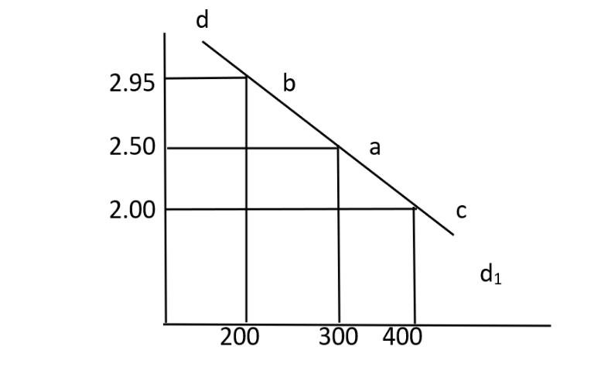

Quantity demanded

Figure 2: Mutation along the same Demand Curve (Source: Author)

When the price of Coffee Frappuccino drink became (£2.50 to £2.95), the demand became (300 to 200 cups). This increase in the price results in the decrease of demand that led to the upward movement of the demand curve (from point a to b). and when the price of coffee became (£2.50 to £2.00), the demand became increase (300 to 400 cups) that led to the downward movement of the demand curve (from point a to c).

IX

1.1.3 Switching of the demand curve and factors pressuring curve to change

According to (Mankiw, 2000), Demand curve switch only if any mutation occurs in the determinants of demand, e.g. change in the price of a close alternative product. Price should not be considered as determinants of demand and it only causes mutation of demand towards the same curve (Mankiw, 2000). Switch of the demand curve is explained below with a diagram:

Price(£)
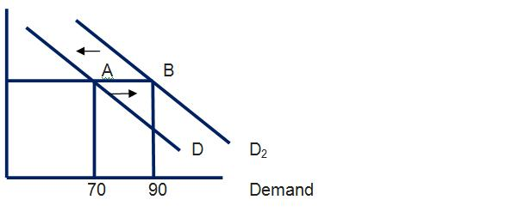

£15

£10

Figure 3: Switching of the demand curve (Source: Author)

Some demand determinants like- income, price of close alternative products, loan opportunity, expectation of increment of the prices in future causes switching of the demand curve. Suppose, a person buys 70 bottles of M soft drinks when the price was £10 some month ago. After some days, he starts to buy more ‘O’ soft drinks than before as ‘M’ close substitute ‘O’ soft drinks’ prices increased though the price is the same as before.

X

Components pressuring demand curve to switch:


Income

 | Components | Price of
Change of | pressures | Price of
Change of | pressures | substitute
Change of | demand | substitute
preference | demand | substitute
preference | curve to be | goods
 | change

Price of
complements
goods

Figure 4: Components pressuring demand curve to switch (Source: Mankiw,2000)

- Income: According to (Mankiw, 2000), When a person income increases, s/he will buy more products or enjoy services than before at each price. For example- a person whose salary increased recently will buy more Coca-Cola bottles than before. Increase in income will cause the demand curve to shift rightward (Mankiw, 2000).

- Price of substitute goods: There is a positive relationship between the prices and demands of substitute products (Mankiw, 2000). If a product price increase, the demand of the products’ substitute will also be increased. For example- if the prices of butter are increased, people will increase the procurement of margarine. As a result, the demand curve will shift to the left side. (Mankiw, 2000).

- Price of Complementary goods: Increase in the demand of one product because of decreased price, demand for other complementary good also increased (Mankiw, 2000). For example- if the demand for printers increased because of the lower price, then the demand for ink cartridges also increased (Mankiw, 2000). It will shift the demand curve to the rightward.

XI

- Change of preference: when people preference changes, their demand also changed (Mankiw, 2000). If consumers start to like tea more than coffee, then the demand for tea is automatically increased which led to the shift of demand curve to the rightward.

1.2 Fundamental discussion of supply law and various aspects of the changing supply curve and some affecting components

1.2.1 Supply law

According to (Whelan and Msefer, 1996), when the price of a product increases, Suppliers increase the supply of the product to the market for maximizing product and when the price goes down, suppliers decreases its supply to mitigate loss and this positive relationship between price and supply is called supply law. For example- a burger shop will increase its supply when the selling price of the burger is going up in the market. This law is true only if some related components remain static such as- static income; no change in technology or production factors; no change in the business or government policies etcetera (Whelan and Msefer, 1996).

Mutation of the supply curve: There are two types of mutation of the supply curve and they are as follows:
- Mutation along the same supply curve

- Mutation of the supply curve

1.2.2 Mutation along the same supply curve

When quantity supplied is changed based on the changes in the product’s price while other factors related to supply remain static, mutation along the same supply curve happens (Brækkan and Eivind, 2015). There are two types of mutation happens along the same supply curve and they are as follows:
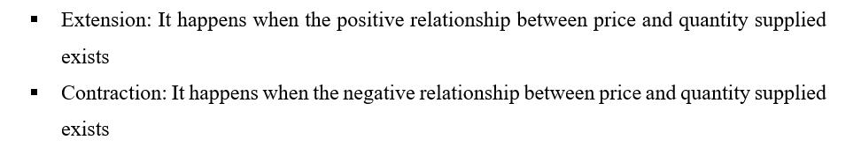

XII

Mutation towards same Supply curve is explained based on the data of Starbucks Iced Coffee (with or without Milk) drink (Starbucks Corporation, 2019):


Figure 5: Supply Schedule of Starbucks Corporation (Source: Starbucks Corporation, 2019)

Price (£)
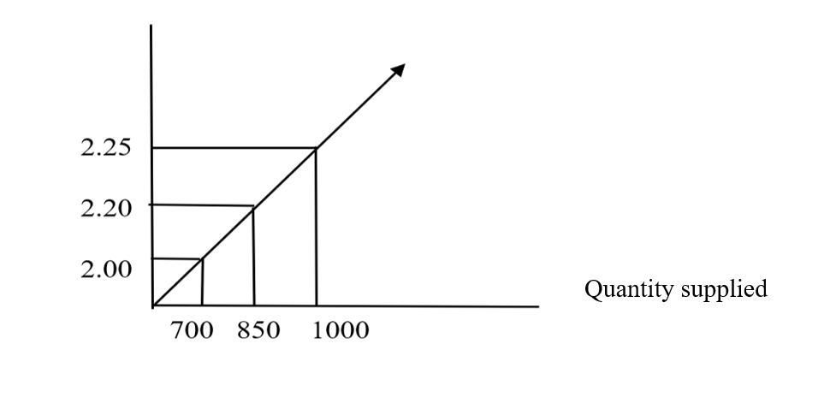

Figure 6: Supply Curve of Starbucks Corporations' Iced Coffee (Source: author)

When Starbucks’ Iced coffee’s price was £2.00, quantity supplied cups were 700, and supply increased to 850 cups when the price increased £2.00 to £2.20 for earning more profit and this situation led to the extension of supply. Starbucks’ quantity supplied of iced coffee decreased to 850 cups from 1000 cups when price decreased to £2.25 to £2.20 for mitigating loss and this situation led to the contraction of supply.

XIII

1.2.3 Switching off the supply curve and factors pressuring curve to change

According to (Mankiw, 2000), Supply curve switch only if any mutation occurs in the determinants of supply, e.g. improvement in the technology engaged in production. It should be remembered that price is not the determinant of supply and can cause a mutation of supply towards the same curve (Mankiw, 2000). Switch of the supply curve is explained below with the diagram:

Price (£)
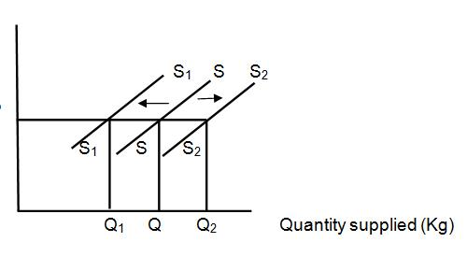

P

Figure 7: Switch of the supply curve (Source: Author)

Supply curve switch when a change in determinants of supply occurs and the determinants are-the price of inputs; improvement or deploy in technology or number of producers (Mankiw, 2000). When the price was P and supply was SS. Because of the development in technology, supply increased to S2S2 which led to the rightward shift of supply curve. When the price of production factors increased, supply decreased to S1S1 which led to the leftward shift of supply curve through at every stage of supply, price was static.

XIV

Components pressuring supply curve to switch:


Price of
production
factors

 | Components
Govt. | pressures
Govt. | supply curve
policies | supply curve
policies | to be
 | switched

Number of
producers

Condition of
technology

Figure 8: Factors pressuring supply curve to switch (Source: Mankiw, 2000)

- Production factors: Due to the increase of tax imposed by China on the USA of £110 billion (Swanson and Rappeport, 2019), Starbucks China had to pay more for importing materials from Starbucks Corporation’s main supply chain located in the USA which ultimately forces the producers to pay more and price of Starbucks’ coffees are increased. As a result, Starbucks China decreased its supply of products and supply curve shifts leftward.

- Condition of Technology: when improved technology is used in the production line, it enhances the efficiency of production or mitigate labor cost. And ultimately units of production increased which led to the rightward shift of supply curve.

- Number of producers: When an industry has a lot of producers, the supply of products is also of big amount and supply curve shifts rightward.

- Government policies: Government policies can affect business decisions directly. Due to COVID-19 outbreak, many countries’ government stopped all the shops of their countries.

As a result, Starbucks Corporation had to stop their production and supply to the market. Overall, the whole coffee industry is concatenated which led to the decrease of supply and a leftward shift of supply curve.

XV
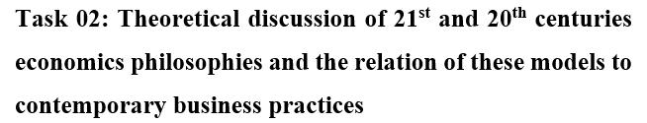

2.1 Innovative economics theory: a contemporary doctrine for the

21st century

Innovative economics, introduced by Joseph Schumpeter in his book called “capitalism, socialism and democracy” in 1942, said that technology, innovation, information, knowledge are the main foundations of economic growth (Robles, 2009). According to (Robles, 2009), innovative economics is based on two doctrines:

- Economic policy should enhance the innovation and greater productivity

- Emphasizing public-private partnership (PPP) in increasing higher productivity and innovation

The bottom line of innovative economics is that economic growth of today’s world does not depend on capital solely suggested by neo-classical economists rather depends on information; technological innovation and overall innovation in every sector (Robles, 2009). For example- US economic growth is being happened not just because of only capital but also the innovation of new production ways; technological evolution in various industries. This theory also suggests that using innovation in business, societies led the development of production factors of industries; extend wealth; quality, or standard of living which ultimately results in producing high-quality products at low cost and creating greater demand for the products (Robles, 2009). India, China, Japan, USA are today’s world giants of innovation in every sector and they made it reality by investing in the research and development sector, high tech parks or industry with patents, export of their innovative products (Robles, 2009). Moreover, because of innovation in the economy, per capita income, social tranquillity; a high standard of living also occurs.

XVI

2.2 Keynesian economics theory: a prominent doctrine of the 20th century

Keynesian economics theory, introduced by John Maynard Keynes during the great depression (the 1930s), discusses total expenditure and its effects on total output; inflation of an economy (Arestis, Filho and Bittes, 2018). Keynes said that the economy can be out of depression if total demand is increased by increasing government spending and setting lower taxes. And (Arestis, Filho and Bittes, 2018) also said that prices and wages of employees decline when aggregate demand decreased resulting in the low production and high layoff. At that time, economic growth can be regained by the increased capital investments and giving jobs to more people by employers (Arestis, Filho and Bittes, 2018). According to (Jahan, Mahmud and Papageorgiou, 2014), Keynesian economics works in three ways:

- Keynesian economics theory suggested that a country’s economy should not be run by only private sector or public sector. There should be a mixed economy- mainly operated by private and some specific sectors operated by the Public sector.

- Change of supply and demand affects wages slowly. For example- if an industry enjoys vast supply and sells products, employees of that industry will not enjoy high or handsome wages in a short time.

- If there is a change in any factors of spending like in consumption, government expenditure, investment, total output, or employment is affected. For example- because of the high demand for luxurious cars stem from high investment in the car industry will require more employees for high production.

XVII

2.3 Comparison of innovative and Keynesian economics theory

Innovative economics theory said that technological innovation, information, knowledge are the main reasons behind economic growth and Keynesian economics theory said that high spending in consumption, investment, government expending can extend the economic growth. Innovative economics theory suggests that investing in innovation can increase the total output and employment rate whereas Keynesian economics theory suggests that an increase in aggregate demand can increase total output and employment rate. Innovative theory emphasizes on innovation and information for advancement whereas Keynesian theory emphasizes on capital investment. From these two theories, Innovative economics theory is more practical than Keynesian theory in the modern age as it is the age of globalization and information.

2.4 Connection of innovative and Keynesian theory to the contemporary

business practises


XVIII

Conclusion
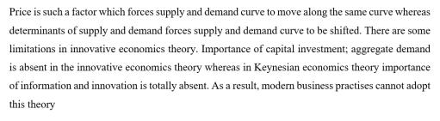

XIX

Bibliography

Whelan, J. and Msefer, K., 1996. ECONOMIC SUPPLY & DEMAND. MIT, pp.2-20.

Ormazabal and Kepa, 1995. The Law of Diminishing Marginal Utility in Alfred Marshall's Principles of Economics. Journal of the History of Economic Thought, 2, pp.91-126.

Brækkan and Eivind, 2015. Why Do Prices Change? An Analysis Of Supply And Demand Shifts And Price Impacts In The Farmed Salmon Market. PhD.

Starbucks Corporation, 2019. Starbucks' Fiscal 2019 Annual Report. Washington: Starbucks Corporation, pp.1-80.

Mankiw, G., 2000. Gregory Mankiw’s Principles Of Microeconomics. 2nd ed. pp.1-7.

Swanson, A., Bradsher, K. and Rappeport, A., 2019. U.S. and China Agree to Roll Back Some Tariffs if Deal Is Struck. The New York Times, p.1.

Robles, D., 2009. A Definition For Innovation Economics - The Ingenesist Project. The Ingenesist Project. pp. 1

Faccarello and Gilbert, 2015. Labour Theory Of Value. pp.245-255.

Arestis, P., Filho, F. and Bittes, T., 2018. Keynesian macroeconomic policy: Theoretical analysis and empirical evidence. Panoeconomicus, 65(1), pp.1-20.

Jahan, S., Mahmud, A. and Papageorgiou, C., 2014. What Is Keynesian Economics? 51(3), pp.2-5.

